**GIT Department of Computer Engineering**

**CSE 222/505 - Spring 2021**

**Homework 2 Report**

**Burak Yıldırım**

**1901042609**

**1. SYSTEM REQUIREMENTS**

**a. JDK**

You need to download JDK 15 to run this homework.

# b. Files

You need default_branch1.txt, default_branch2.txt, default_branch3.txt, default_branch4.txt, default_branch_employees.txt, default_administrators.txt and default_store_house.txt files to initiate the automation system and a menu like driver.java to interact with the system.

**1. USE-CASE AND CLASS DIAGRAMS**

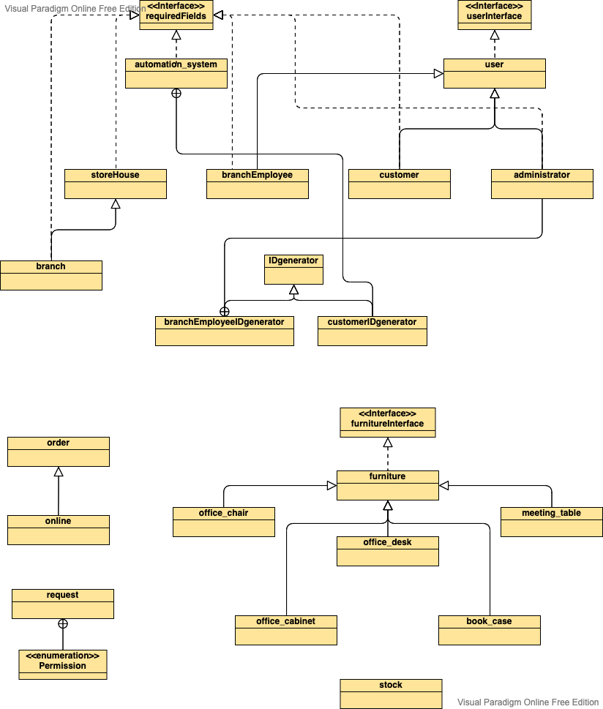

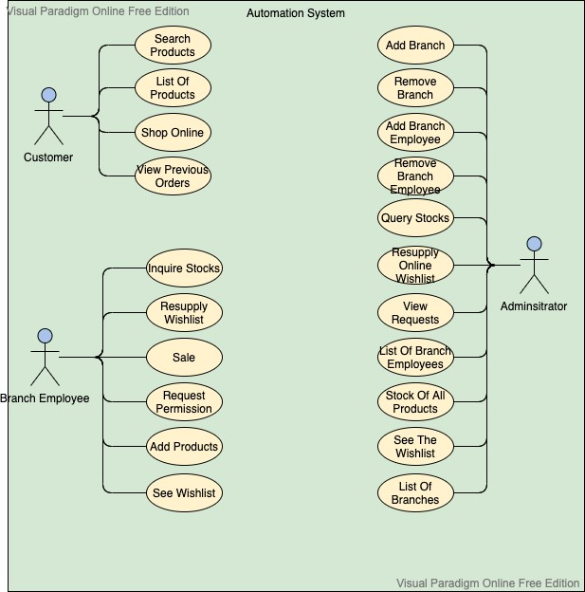

# PROBLEM SOLUTION APPROACH

To solve this assignment I created automation_system, administrator, customer, branchEmployee, branch, storeHouse, branchEmployeeIDgenerator, customerIDgenerator, KWLinkedList, KWArraylist and HybridList classes .

# TEST CASES && RUNNING AND RESULTS

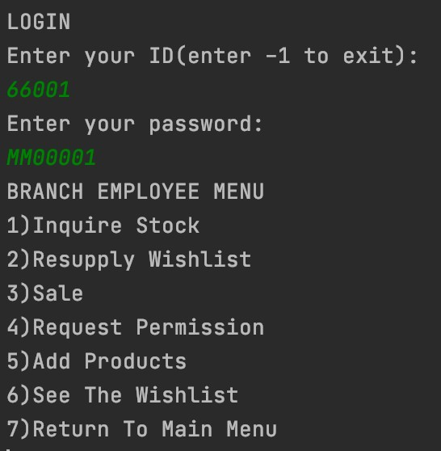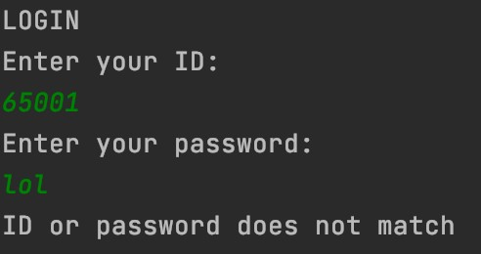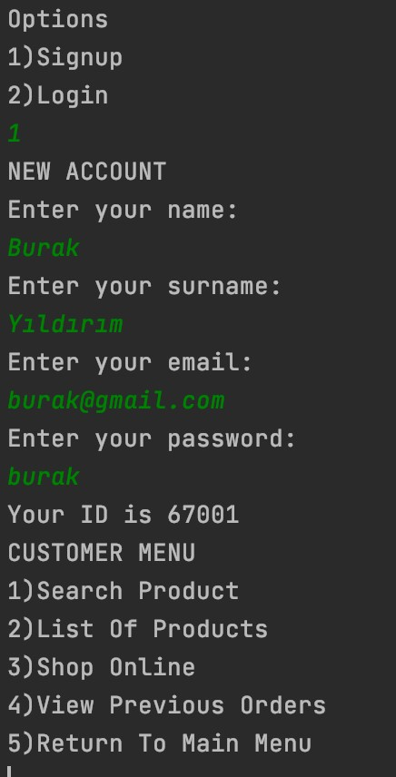

I use a function to check the validity of input so this error catching is valid for all functions that takes user input

If customer selects search product and then selects branch stocks

If customer selects list of products

If customer selects shop online

If customer selects view previous orders



If branch employee selects inquire stocks then selects see the stock info of a specified product

If branch employee selects sale

If branch employee selects resupply wishlist before getting administrator’s permission



To get the administrator’s permission branch employee should select request permission

After getting administrator’s permission



If adminstrator selects add branch

After add branch

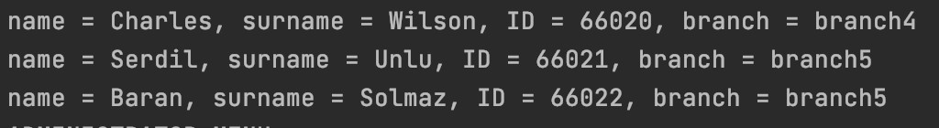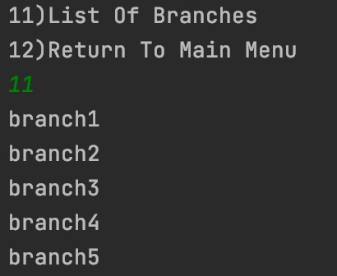

If administrator selects remove branch employee and enter 66001 as ID Before

After

If administrator select remove branch

Before

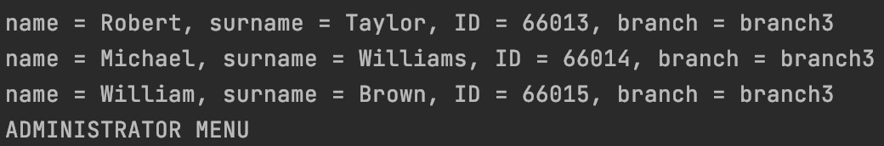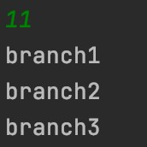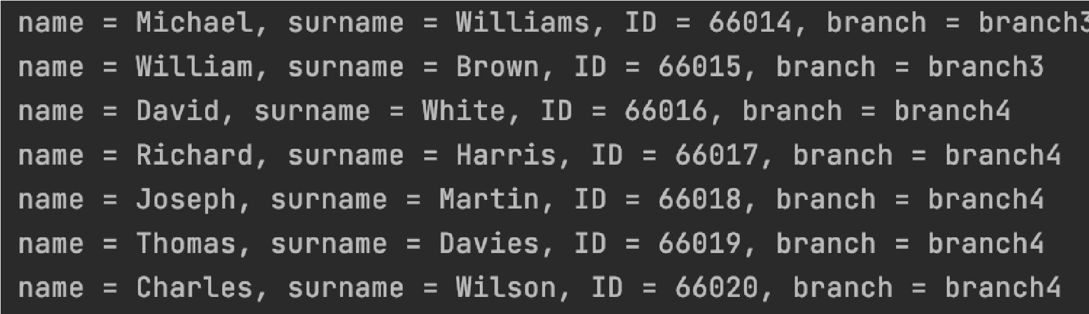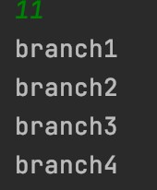

After

If administrator selects resupply online wishlist



If administrator selects see wishlist(I do this with seeWishList function and I also use it for branch employee see wishlist option so that this is also valid for branch employee see wishlist option)

